Site Selection Guidelines

When selecting sites for hydrological monitoring stations, the purpose of the site, appropriateness for monitoring the parameter of interest, existing infrastructure, access, and security should be considered. Once the general location has been determined, the actual site for placement of the instrumentation must be selected. A combination of remote sensing/GIS can be used to evaluate the potential location followed by a field visit to confirm its appropriateness. Baseline criteria to evaluate the sensor locations include:

Physical consideration (exposure, aspect, slope, elevation, river morphology)

Site footprint

Existing infrastructure/monitoring stations

Vegetation

Physical Access

Telemetry window (for telemetry systems)

Power source. If solar is to be used, does the site have a sufficient solar window.

Security

Land ownership

Aesthetics

The following sections provide further guidance for each of the primary types of hydromet monitoring stations including a list of criteria to consider when selecting a specific site.

# Common for all stations

The site should be readily accessible by motor vehicle during all weather and streamflow conditions. Requests for permission to install and access the site should be submitted to property owners or managers before the onset of construction.

The site should be cleared of brush and other obstructions that would make access hazardous and the grounds surrounding the station should be maintained in this manner throughout the AMC period.

## Questionnaire

Will data from this site meet the objectives of the monitoring network by providing a representative sample of the basin or sub-basin of interest?

Will the site be susceptible to flooding?

Would it be feasible to power the monitoring instruments and telemetry equipment with a solar panel and battery system or is enough sunlight available to charge the battery?

Is the site easily accessible by road to facilitate the operation and maintenance of the instruments and housing structure?

Has land ownership and security been considered?

# Automatic Rain Gauge

The main purpose of establishing a rainfall monitoring station is to obtain representative samples of the rainfall over a basin. Site selection for the rain gauge instrument is critical for obtaining a representative sample. Conditions around the gauge affect its effectiveness in collecting a sample that accurately reflects the area that it is designed to represent. Particularly, wind affects the rainfall measurements, while further losses due to evaporation and splashing also play a role. To eliminate or reduce wind effects the site should be chosen such that the wind speed at the level of the rain gauge is as low as possible, but in such a way that the surrounding environment does not significantly affect the rain catch.

Ideally, protection against the force of wind should come from all directions by objects of uniform height. Trees, shrub, etc. of nearly uniform height are ideal to protect the gauging site from wind, provided that the angle from the top of the gauge to the top of the encircling objects and the horizontal is between 30o and 45o. Windbreaks of a single row of trees or a building (currently present or to be constructed) should be avoided as they tend to increase the turbulence (WMO, 1994).

Slopes also affect the wind field. Sites on a slope or with the ground sloping sharply away in one direction (particularly in the direction of the wind) are to be avoided.

The gauge should be on level ground above flood level and free from water logging. Further, the site should have the same ground cover as the natural cover in the surrounding area. Surroundings covered with short grass are ideal. A hard ground such as concrete gives rise to excessive splashing and should be avoided. The plot required for an automatic rain gauge (ARG) station is 10 m x 5 m.

Ideally, the rain gauge should not be installed on top of buildings as per WMO guidelines. However, if the land availability and site security are the consideration, the rain gauge may be installed on roof of building in some specific cases.

The site should be away from any obstruction. If there is a tree or a building nearby, the distance of rain gauge should be **at-least** twice the height of building. (L>2H, where H is height of obstruction; and L is distance of rain gauge from obstruction). See the figure below for explanation.

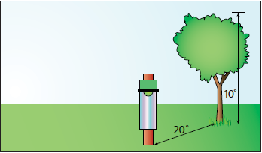

## Questionnaire

Is the distance of rain gauge at-least twice of the height of nearest obstruction?

Are there any strong winds?

Is the ground surrounding the rain gauge a flat ground having no slopes?

# Automatic Weather Station

Since an automatic weather station (AWS) includes rain gauges, the environmental conditions discussed above for rainfall stations apply for the AWS as well. It is essential in the case of an AWS that the area on which the station is to be built is representative for a surrounding area of about 5,000 km2. Sites where abrupt climatic differences are noticed due to swamps, mountains, river gorges and lakes should be avoided, unless data are needed to specifically represent such an area.

For agricultural purposes the station should be within a cultivated area with a crop cover as large as possible upwind. Depressions should be avoided as the temperature in depressions is frequently higher during the day and cooler in the night.

To get a proper assessment of the potential evapo-transpiration the site should be in the center of an open space of at least 50 m x 50 m, which is covered by grass or a short crop. (This is not actual requirement of land for installing the station but area nearby should preferably be open space) If needed and feasible, the grass cover of the station should be irrigated and clipped frequently to fulfill the environmental conditions of the definition of potential evapo-transpiration.

# Water Level Stations

Water level or “stage” is a relatively easy parameter to measure in the riverine environment and thus is commonly monitored as a means to compute discharge or flow based on the relation between stage and discharge. This relation is commonly known as the “stage-discharge rating”. Therefore, in many circumstances the selection of a stage or water level measurement site will be to a certain extent governed by the suitability of the site for making accurate discharge measurements. However, in some situations, stage is the primary hydrologic parameter of interest such as in determining the storage volume in reservoirs or for flood forecasting.

In either case, whether stage or discharge is the parameter of interest, the stage monitoring station should be located at a site on the river that is characterized by steady, uniform flow with stable physical channel features that result in readily discernible changes in stage associated with changes in discharge. Zones of high turbulence, eddies, and super elevation, such as on the outside of river bends, should be avoided.

The channel should be contained within a single channel with stable banks. The picture below shows a section of breading river, where a water level station should **NOT** be installed.

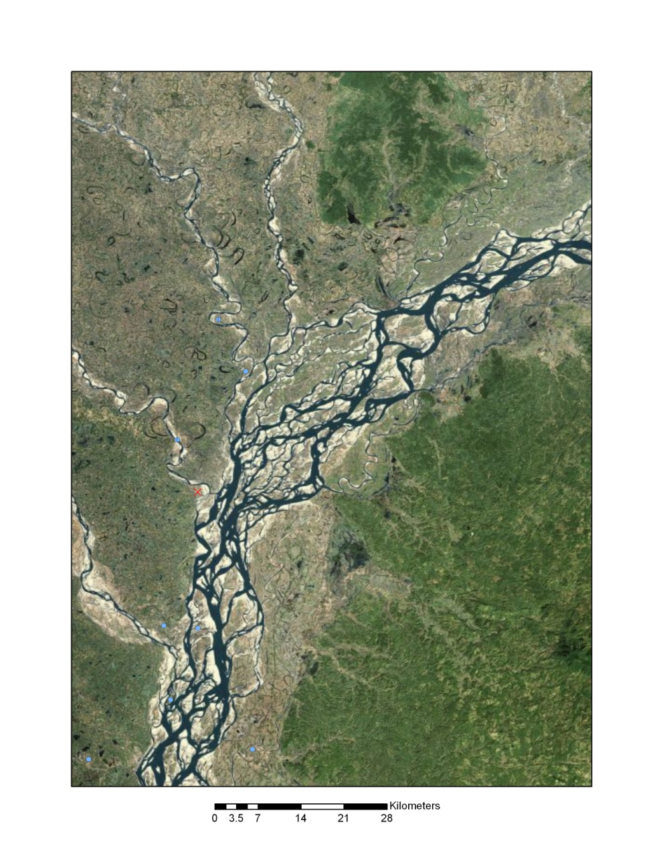

The channel should be relatively narrow in relation to the cross-sectional area so that the stage sensor will be submerged over the expected range of stage. Ideally the stage sensor should be deployed within 10-20 meters of the river’s historic high-water mark where the instrument shelter is located to house associated equipment without risk of flooding.

According to the WMO, the general course of the stream is straight for about 10 times the stream width, upstream and downstream from the gauge site. The picture below shows a site where there is a bend after bridge; hence it is NOT a good site for water level monitoring.

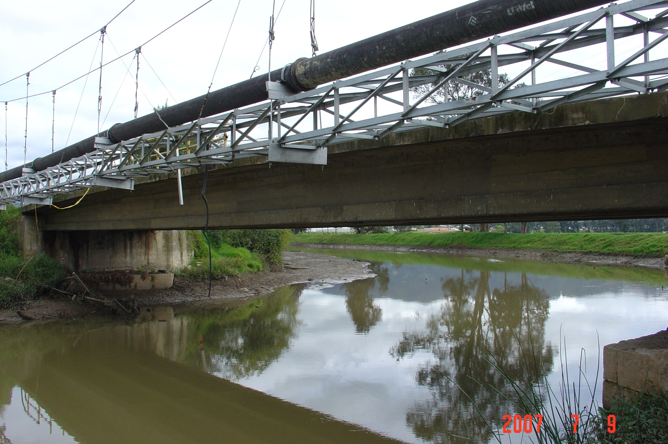

Apart from straight section, the approach velocities should be evenly distributed, and cross sections should be avoided where sediment deposition/scour is prevalent.

Establishing and maintaining datum is critical for stage monitoring as it provides the underlying basis for the calibration of the sensors. Thus benchmarks should be located within approximately 100 m of the proposed site to serve as the basis for gauge datum. If no such benchmarks currently exist at the site, plans should be made to establish a new benchmark using survey grade GPS equipment.

## Bubbler

The preferred location for the installation of in stream sensors is in a deep pool not subject to sedimentation, turbulence, or wave motion.

In-stream sensors should be installed in such a manner as to avoid pileup or drawdown of the water surface in the vicinity of the sensor, thus affecting the accuracy of the data. Pileup can occur on the upstream side of an obstruction in the flow whereas drawdown can occur on the downstream side of an obstruction.

The water level in the gauge pool should have a stable control at all stages. Low stages are best controlled by bedrock in the bottom of the channel, medium and high stages are best controlled by a stable channel or bridge opening downstream of the gauge pool. Locations where part of the flow can bypass the water level sensor in a separate channel should be avoided.

# Discharge

In selecting a site for a new stream flow discharge station the following considerations should be addressed in addition to those listed in the previous section for “Water Level” stations.

As previously mentioned the stage-discharge rating is the key tool used in converting field measurements of stage into computed discharge at a specific site. Stage is easily monitored using a variety of sensors, each having its own advantages and disadvantages and applicability under varying field conditions. Discharge is measured periodically over a wide range of flow conditions and the value is plotted against the measured stage at the time of the discharge measurement to construct the stage-discharge rating. The shape and stability of the channel at the gauge location has a direct impact on the shape and stability of the stage-discharge rating. Physical properties of the channel called “controls”, located downstream of the gauging station are what dictate the shape and stability of the rating curve. Common controls at low flows include bedrock or other stable channel bottoms and are called “section controls”. At medium and high flows the stage-discharge relation is often controlled by the shape of the channel banks or a physical constriction such as a bridge. Typically, no single control is effective for the entire range of flow conditions but instead there exists what is referred to as a compound control. An example would be where a bedrock section control exists at low stages and the channel geometry controls the stage-discharge relation at medium and high stages. A control is stable if the stage-discharge relation it defines does not change with time; otherwise it is referred to as a shifting control.

Controls can be natural or artificial (manmade for flow measurement purposes). Artificial controls may be purposely built flow measurement structures such as weirs or flumes, which have a theoretical stage - discharge relation unique to the structure. Reservoir spillways, control weirs and anicuts frequently come into the ‘artificial’ category, even though they have not been intentionally built for flow measurement purposes, since it is often possible to derive theoretical stage-discharge relations for them. Structures, which have not been constructed for the purpose of flow measurement such as bridges, floodway channels and drifts, are not considered as artificial controls since they normally require full rating development. Stage-discharge gauging stations such as natural controls and non-purpose built structures, which require current meter gauging to define the stage-discharge relations are often referred to as rated sections.

The two most important attributes of a control are stability and sensitivity. If the control is stable the stage-discharge relation will be stable. It is also important that the control is sensitive, i.e. small changes in discharge should correspond to relatively small but easily measureable changes in stage. It is a primary requirement for stage-discharge gauging stations that the rating relation should be as sensitive over as wide a range of flows as possible. In other words, any change in the recorded water level should correspond to a relatively limited (in percentage rather than absolute terms) change in flow.

The site should be located outside the backwater zone of confluences with other rivers, tidal influence, and other structures that impede the flow of water. The extent of the backwater reach L is approximately:

where: L = approximate reach of the backwater effect

hn = normal or equilibrium depth

S = slope of the river bed

## Questionnaire

Will data from this site meet the objectives of the monitoring network by providing a representative sample of the basin or river reach of interest? If not, what is the rationale for selecting this site over a more representative site.

Will turbulence or superelevation of the water surface due to channel hydraulics or alignment have a negative effect on the accuracy of the stage measurement? If yes, look for an alternate site with a straight channel alignment for a distance equal to approximately five channel widths upstream of the monitoring site.

Is the flow at the site confined to a single channel at all stages with no flow bypassing the gauging station location in a separate channel? If no, consider an alternate site with flows at all stages confined to a single channel.

Is the channel at the gauging station location subject to significant scour and fill of the bed or does it have large amounts of aquatic growth during warm periods. If yes, consider an alternate site with a more stable channel.

Are the banks near the proposed site above the maximum high water level so that dataloggers and other associated equipment can be secured without risk of flood damage?  
If no, consider an alternate site.

Is a stable natural control present in the form of a bedrock outcrop or stable riffle at low flows and a confining channel at medium to high flows? Is a pool is created by the control so that river stage can be effectively monitored at even the lowest flows? If no, consider an alternate site.

Is the gauge located far enough upstream from the confluence of another river, constriction, or tidal zone to avoid being influenced by backwater? If no, consider an alternate site taking care to avoid the influence of backwater.

Is there a good cross section for making discharge measurements located near the gauging site? Remember that it is not necessary that low and high flow measurements be made at the same location. However, there should be no gains or losses in flow between low and high flow measurement sections. If no, consider an alternate site with better choices for making discharge measurements.

Is telemetry of data a requirement for this station? If yes, select the most appropriate type of telemetry based on the factors described in the Hydrological Information Manual

Is power available at the site and if not, would it be feasible to power the monitoring instruments and telemetry equipment with a solar panel and battery system?

Is the site easily accessible by road to facilitate the operation and maintenance of the instruments and housing structure during all flow and weather conditions?

Is the site is secure to avoid vandalism or theft of instruments and civil structures.  
If No, consider an alternate site.

Has land ownership and security been considered? If no, these issues need to be addressed or an alternate site considered.

# Sediment

The selection of sites for sediment sampling and monitoring depends largely upon the objective of the data collection effort. Unlike rainfall monitoring where the network is designed to provide representative coverage for a large area, sediment monitoring is most often tied to site-specific issues. For example, bridge designers require knowledge of bed scour at the proposed site in order to know how deep to build the abutment footings, or in identifying a site for a dam and reservoir it is necessary to have information on sediment transported by the streams upstream of the reservoir in order to determine its useful life and at what point a dredging program might be necessary to extend that life. The location of sediment monitoring stations to address these kinds of issues is therefore tied to the site-specific problem being addressed rather than to provide basin-wide values for general statistical analyses. However, the following general guidelines should be made when selecting a sediment monitoring site:

## Questionnaire

Will data from this site meet the objectives of the monitoring network by providing a representative sample of the basin or river reach of interest? If not, what is the rationale for selecting this site over a more representative site.

Is there a stream gauging station located in the vicinity of the proposed monitoring site to provide flow data for sediment load computations or as model input? If no, consider an alternate site near an existing stream gauging station or include the installation and operation of a gauging station as part of the sediment monitoring plan.

Is the flow at the site confined to a single channel at all stages with no flow bypassing the proposed monitoring location in a separate channel? If no, consider an alternate site with flows at all stages confined to a single channel.

For large rivers, is a bridge is available in the reach of interest from which to sample? In the absence of a bridge will it be feasible to operate a boat over the range of expected flow conditions from which sampling can be done? If no, consider an alternate site with a bridge or where sampling from a boat is feasible at all flows.

Is there a good cross section located at the monitoring site for sampling sediment during all flow conditions? If no, consider an alternate site with a cross section in which the sediment (bedload and suspended load) can be sampled accurately and safely.

Are the banks near the proposed site above the maximum high water level so that dataloggers and other associated equipment can be secured without risk of flood damage. If no, consider an alternate site.

Is the site far enough downstream from tributary inflows so that water and sediment from the two streams are well mixed at the monitoring site? If no, consider an alternate site farther downstream where mixing of water and sediment from the two rivers is complete.

Is power available at the site and if not, would it be feasible to power the monitoring instruments and telemetry equipment with a solar panel and battery system? If no, consider an alternate site.

Is the site easily accessible by road to facilitate the operation and maintenance of the instruments and housing structure during all flow and weather conditions? If no, consider an alternate site.

Is the site is secure to avoid vandalism or theft of instruments and civil structures. If No, consider an alternate site.

Has land ownership and security been considered? If no, these issues need to be addressed or an alternate site considered.

# Water Quality

The selection of sites for water-quality sampling and monitoring depends largely upon the objective of the data collection effort. As with sediment monitoring, the location of water-quality monitoring is often tied to specific issues. However, some water-quality networks are designed to represent the water-quality over large regions in an effort to ascertain long-term trends. The location of water-quality monitoring may be designed to address site-specific issues, to provide basin-wide values for general statistical analyses, or both. The following are some general guidelines that should be taken into account when selecting a water-quality monitoring site:

## Questionnaire

For surface-water quality monitoring is there a stream gauging station located in the vicinity of the proposed monitoring site to provide flow data for water-quality constituent load computations or as model input? If no, consider an alternate site near an existing stream gauging station or include the installation and operation of a gauging station as part of the water-quality monitoring plan.

Is the flow at the site confined to a single channel at all stages with no flow bypassing the proposed monitoring location in a separate channel? If no, consider an alternate site with flows at all stages confined to a single channel.

For large rivers, is a bridge is available in the reach of interest from which to sample? In the absence of a bridge will it be feasible to operate a boat over the range of expected flow conditions from which sampling can be done? If no, consider an alternate site with a bridge or where sampling from a boat is feasible at all flows.

Is there a good cross section located at the monitoring site for sampling water-quality constituents during all flow conditions? If no, consider an alternate site with a cross section in which the water-quality constituents of interest can be sampled accurately and safely.

Are the banks near the proposed site above the maximum high water level so that dataloggers and other associated equipment can be secured without risk of flood damage.  
If no, consider an alternate site.

Is the site far enough downstream from tributary inflows so that water and water-quality constituents from the two streams are well mixed at the monitoring site?  
If no, consider an alternate site farther downstream where mixing of water and water-quality constituents from the two rivers is complete.

For groundwater quality monitoring does the well proposed for QW sampling have access ports from which water samples can be drawn? If no, consider another well with access ports or include plans to install a port from which water-quality samples can be drawn.

Is power available at the site and if not, would it be feasible to power the monitoring instruments and telemetry equipment with a solar panel and battery system? If no, consider an alternate site.

Is the site easily accessible by road to facilitate the operation and maintenance of the instruments and housing structure during all flow and weather conditions? If no, consider an alternate site.

Is the site is secure to avoid vandalism or theft of instruments and civil structures. If No, consider an alternate site.

Has land ownership and security been considered? If no, these issues need to be addressed or an alternate site considered.

# Groundwater

The main purpose of establishing a groundwater monitoring network is to obtain representative samples of water levels throughout an aquifer of interest. Site selection for monitoring stations is critical for adequate representation of the hydrologic conditions in the aquifer. Monitoring stations spaced too far apart result in an inaccurate understanding of the physical hydrology of the aquifer whereas monitoring stations placed too close together can generate redundant data and unnecessarily increase the costs of the network. The selection of sites for groundwater level monitoring depends largely upon the objectives of the data collection effort however the following general considerations should be made when selecting individual monitoring sites:

## Questionnaire

Will the data generated from this site add to the overall understanding of the physical hydrologic properties of the aquifer? If no, consider an alternate site.

Is the information generated by this monitoring station regarding the aquifer’s hydrologic properties redundant? In other words, do existing monitoring stations already provide this information? If yes, consider eliminating this station from the network.

Do operational wells with pumps being proposed for monitoring have access ports for deploying instruments and ideally have a separate conduit to keep the AWLS communication or support cables from interfering with the pump or electrical cables? If no, consider another well with access ports or include plans to install a port through which water-level sensors and cabling can be installed.

Is power available at the site and if not, would it be feasible to power the monitoring instruments and telemetry equipment with a solar panel and battery system? If no, consider an alternate site.

Is the site easily accessible by road to facilitate the operation and maintenance of the instruments and housing structure during all flow and weather conditions? If no, consider an alternate site.

Is the site is secure to avoid vandalism or theft of instruments and civil structures? If No, consider an alternate site.